# Merging Records

Contents

Merging Records 1

I. Notes 1

II. Merging the records 1

III. Post-Merge Clean-up 1

## I. Notes

**Merging records should only be undertaken with explicit permission from Development Operations Leadership** Once you merge two records this cannot be undone. When undertaking the merging of two records, you must be certain that they belong to the same person or couple—matching addresses, constituent information, or confirmation by donor/relationship manager. RE does not allow individual records to be merged with organizational records. If, for some reason, you need to merge the two, talk to the Systems and Operations Coordinator.

If you want to merge a constituent that has a solicitor, talk to the constituents’ Relationship Manager before merging.

Primary Record: The older record (lower first four of Constituent ID) which will receive the merged data. It’s best to keep the record that has the oldest constituent ID so it doesn’t appear as a newly created record.

Secondary Record: The newer record (higher first four of Constituent ID) which will be marked for deletion.

## II. Merging the records

1. Open the primary record.
2. From the menu bar at the top of the donor record, select Constituent/ Merge/ merge a constituent into this record.
3. Search for the duplicate record (use Constituent ID) and click open

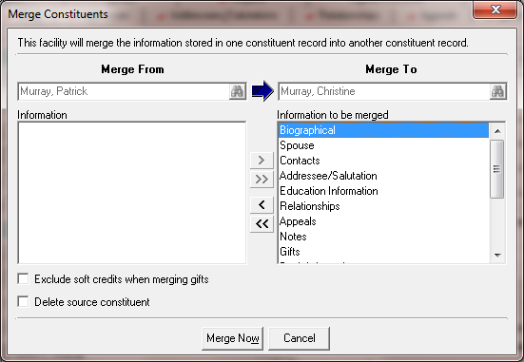

1. Click on the double arrows to bring over all the information as shown above
2. DO NOT check the “delete source constituent” box at this point.
3. Click the Merge Now button

## III. Post-Merge Clean-up

1. Open the primary record
   1. Open the Alias section (next to the last/org name) and write in the secondary Constituent ID. Choose Merged ID from dropdown.
   2. In the Bio 2 tab, clean up duplicate constituent codes.
   3. Add a notepad: Type—Merge Details; Title—Merged from [secondary ID]; Notes—Details of/reasons for merge, such as e-mail requesting merge
2. Secondary
   1. Add attribute: Category—Delete record; Description—Yes; Date—current date